**Guess Paper- 2013**

**Subject: PHYSICS**

**Class XIIth**

**Time Allotted: 3hrs. Max. Marks : 70**

***General Instructions:***

1. ***All questions are compulsory.***
2. ***There are 29 questions in total. Questions 1 to 8 carry one mark each, questions 9 to 16 carry two marks each, questions 17 to 25 carry three marks each and questions 27 to 29 carry five marks each.*Question 26 is a value-based question and carries 4 marks.**
3. ***There is no overall choice. However, an internal choice has been provided in one question of two marks, one question of three marks and all three questions of five marks each. You have to attempt only one of the given choices in such questions.***
4. ***Use of calculators is not permitted.***
5. ***You may use the following physical constants wherever necessary :***

***c = 3 x 108ms-1 h = 6.6 x 10-34Js e = 1.6 x 10-19 Cµo = 4πx 10-7A-1 m T***

***Boltzmann constant k = 1.38 x 1023 JK-1 Avogadro’s number NA = 6.023 x 1023/mole***

***Mass of neutron mn = 1.6 x 10-27 kg***

**Name of student:………………………………………………Exam. No:………………….**

1. The electric current in the direction from B to A is decreasing. What is the direction of induced current in the metallic loop kept above the wire as shown:

A B

1

1. The graph between energy stored (U) in a variable capacitor and capacitance (C) is shown below:

U

Which of the two: the charge or the potential used is kept constant?

C 1

1. Two heating coils, one of thin wire and the other of thick wire, made of the same material and of the same length are connected one by one to a source of electricity. Which of the two will produce heat at a greater rate? 1
2. Name the phenomenon responsible for the brilliance of diamonds. 1
3. The graph between stopping potential and frequency of incident radiations for two different metals A and B are shown:

Vs A B

0 6 12 ν (x 1014 Hz)

What is the ratio of the work function of A to that of B? 1

1. What do you mean by ‘repeater’ in communication systems? 1
2. Mention any two factors that influence the internal resistance of a primary cell. 1
3. What is the frequency range for the standard AM broadcast? 1
4. Show that the force acting on each plate of a parallel plate capacitor is ½ QE, where Q is the charge on each plate and E, the electric field between the plates. 2
5. Define magnetic susceptibility of a material. Name two elements, one having positive

susceptibility and the other having negative susceptibility. What does negativesusceptibility

signify? 2

1. N spherical droplets, each of radius r, have been charged to have a potential Veach. If allthese droplets were to coalesce to form a single large drop, whatwould be the potential of this large drop? 2
2. 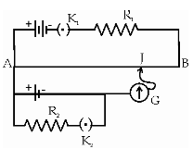State the second postulate of Bohr Atom Model. Hence obtain the same using the concept of de- Broglie’s ‘matter waves’. 2
3. In the given circuit of a potentiometer,

(i) What happens to the balancing length, on increasing

the value of R2?

(ii) What purpose does the resistance R1 serve?

2

1. How do the ‘doping’ and ‘width of the depletion region’, in a zener diode, compare with that of an ordinary p-n junction diode? Draw the circuit diagram to show the use of zener diode as voltage regulator. 2

**(OR)**

With the help of Truth Table, identify the logic operation performed by the following

combination of gates.

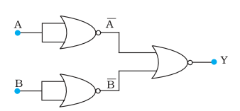

2

1. The figure shows a modified Young’s double slit experimental set up.

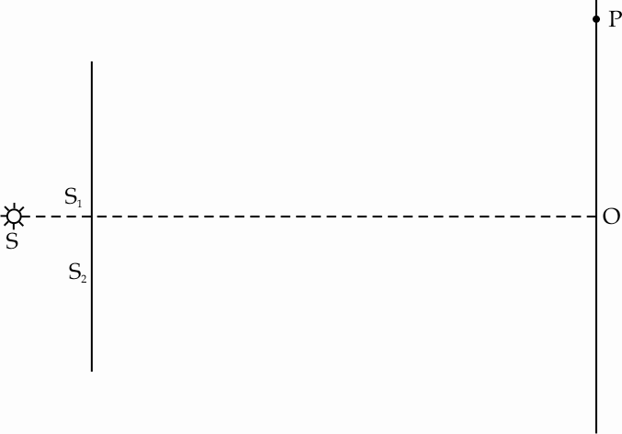

If SS2 – SS1 = λ/4,

(i) State the condition for constructive and destructive interference

(ii)Does the central fringe observe in the above set up lie above or below the point O?

Justify your answer. 2

1. Explain Maxwell’s theory of electromagnetic waves. What is the phase difference between electric and magnetic fields associated with an electromagnetic wave? Which physical quantity, if any has the same value for waves belonging to the different parts of the electromagnetic spectrum? 2



1. A conducting rod PQ of length ‘l’ is moving with a uniform velocity ‘v’ in a uniform magnetic field ‘B’ as shown in the figure.

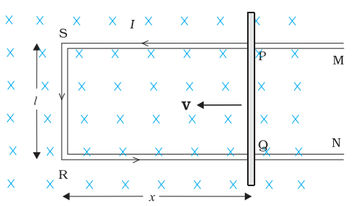

Obtain an expression for the induced emf

developed in the rod.

3

1. 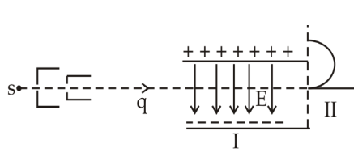A fine pencil of protons, moving with a speed v, enters a region (region I), where a uniform electric and a uniform magnetic field are both present. These protons then move into region II where only the magnetic field, (out of the two fields present in region I), exists. The path of the protons in the tworegions is as shown in the figure.

(i) State the direction of the magnetic field.

(ii) State the relation between ‘E’ and ‘B’ in region I.

(iii) Drive the expression for the radius

of the circular path of the protons

inregion II.

If the magnitude of magneticfield, in region II, is changedto n times its earlier value,

(without changing themagnetic field in region I)find the factor by which the radius of

this circular path would change. 3

1. A convex mirror is placed at a distance‘s’ behind a convex lens of focal length ‘f’. A point object is situated on the axis at the same distance‘s’ from the lens and its image coincides with the object. Show that the focal length ‘fm’ of the mirror is given by

$$f_{m}=\frac{s(2f-s)}{2(s-f)}$$

3

1. Define ‘wavefront’. State Huygen’s principle. Hence verify Law of reflection using the principle.

(**OR)**

(a) Why we do not encounter diffraction effects of light in everyday observations?

(b) In the observed diffraction pattern due to a single slit, how will the width of central

maximum be affected if

(i) the width of the slit is doubled.

(ii) the wavelength of the light used is increased?

Justify your answer in each case. 3

1. 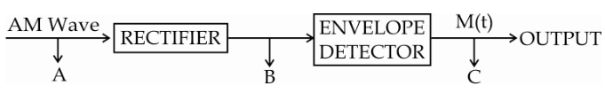Mention any two characteristics of a good ‘detector’ used in the process of communication. Draw the waveforms for the (i) Input AM wave at A, (ii) output, B, of the rectifier and (III) output signal, C, of the envelope detector shown below:

3

1. Light of wavelength 2500 Ao falls on a metal surface of work function 3.5 eV. What is the kinetic energy (in eV) of (i) the fastest and (ii) the slowest electrons emitted from the surface?

If the same light falls on another surface of work function 5.5 eV, what will be the energy of emitted electrons? 3

1. Using Gauss’s theorem, derive the expression for the electric field intensity at a point (i) inside and (i) outside a thin spherical shell of radius R and surface charge density σ C/m2. 3
2. The horizontal component of the earth’s magnetic fieldat a certain place is 3.0 ×10–5 T and the direction of the field is fromthe geographic south to the geographic north. A very long straightconductor is carrying a steady current of 2A. What is the magnitude and direction of the force perunit length on it when it is placed on a horizontal table and thedirection of the current is (a) east to west; (b) south to north? 3
3. Read the following carefully:

**The T.V news about protests against the Nuclear Power Plant in Koodankulam,**

**TamilNadu,madeKiran, a grade 10 boy, dull and disturbed throughout the day. He**

**thought: “Weare in energy crisis, but human lives are more precious than anything**

**else”. He decidedto study more about such Power Plants. He realized certain facts:-**

**Nuclear Power Plants can provide a large source of energy using‘Controlled Chain**

**Reaction’ in the Nuclear Reactors and it can be utilized forproduction of electricity.**

**India has vast Thorium reserves and currentlyproduces 4780 MW of electricity from**

**Nuclear Power Plants.However, the disposal ofnuclearwastes and the chance of**

**leakage of harmful radiations during the functioning ofsuchplants pose danger tothe**

**people reside near the area of the Power Plant. Theconcern onthe safety measures**

**takenby the Government in this direction and therecentFukushimaNuclear disaster**

**are the majorreasons for the protests lodged by thepeople, especially incoastal areas.**

**Further, he read about another nuclear reaction, called ‘Nuclear Fusion’ which does**

**not produce any dangerous nuclear wastes!**

**Kiran, discussed about these issues with his friends and all of them agreed to**

**organize a campaignin the school with the title “Right to Live with Safe and Clean**

**Energy”.“In future, we will surely find the method of converting the radioactive waste**

**into less active and short-lived material, to save human lives.- Kiran declared with**

**confidence.**

**Now, answer the following:**

**(i) How is nuclear fission reaction controlled in reactors?**

**(ii) What is nuclear fusion? Is it safe and clean? Why such a reaction cannot be carried**

**out inreactors?**

**(iii) What, according to you, are the values shown by Kiran? 4**

1. 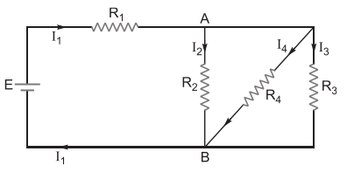In the circuit shown, E = 12 V, R1= 4.5 , R2 = R3 = 6  and R4 = 3 . Determine the equivalent resistance and current through each resistor.

3

1. (i) Show that an ideal inductor does not consume any electrical power, when connected to an

a.c. circuit.

(ii) An A.C source of angular frequency  is fed across a resistor R and a capacitor C in

series. The current registered is I. If now the frequency of the source is changed to /3

(but maintaining the same voltage), the current in the circuit is found to be halved.

Calculate the ratio of reactance to resistance at the original frequency . 5

**(OR)**

(i) Obtain the expression for the average emf of an a.c. supply during half a cycle.

(ii) A series circuit containing two pure elements has the following applied voltageand   
 current:-

V = 200 sin (2000t + 50o) volts

I = 4 cos (2000t + 20o) amperes.

Calculate the values of the elements in the circuit. 5

1. A student has to study the input and output characteristics of an n-p-n transistor in the Common Emitter configuration. What kind of a circuit arrangement should he use for this purpose?

Draw the typical shape of input characteristics likely to be obtained by him. What do we

understand by the cut off, active and saturation states of the transistor? In which of these

states does the transistor not remain when being used as a switch? 5

**(OR)**

With the help of a neat circuit diagram, explain the working of a transistor as an oscillator.

What are the Burkhausen criteria associated with an oscillator?

How will the (i) current gain and (ii) trans-conductance of a transistor change on increasing

the doping level of base region? 5

1. (a) Draw the ray diagram showing the geometry of formation of the image of a point object situated on the principle axis, and on the convex side, of a spherical surface of radius of curvature R. Taking the rays as incident from a medium of refractive index n1 to another of refractive index n2, show that

$$\frac{n_{2}}{v}-\frac{n_{1}}{u}=\frac{n_{2}-n_{1}}{R}$$

where the symbols have their usual meaning.

(b) Use this relation to obtain the (thin) lens marker’s formula. 5

**OR**

1. Draw a ray diagram showing the passage of light through a glass prism. Hence obtain a relation between the angles of deviation, incidence and emergence and the angle of prism.
2. Show that no ray can pass through a prism whose refracting angle A is greater than twice the critical angle for the material of the prism.

**Submitted by:**

**M.Rajeev,**

**H.O.D (Physics) Sharjah Indian School Sharjah U.A.E**

**Sharjah Indian School**